**Assignment 2:**

**Visual Information Retrieval**

**Jason Mann**

**3/12/13**

**COMS 4735: Visual Interfaces for Computers**

Table of Contents

**Application OverView 3**

**Assignment Detail 4**

**Part 1: Gross Color Matching 4**

**Part 2: Gross Texture Matching 5**

**Part 3: Combine Similarities and cluster 6**

**Part 4: Creativity with D3 7**

**OutPut 8**

**Color Matching 8**

**Color Max/Min 13**

**Texture Matching 13**

**Texture Max/Min 18**

**Combo Matching 18**

**Combo Max/Min 21**

**Complete List Dendrogram 22**

**Complete List Dendrogram 28**

**Code 35**

**ImageMatching.pro 35**

**main.cpp 35**

**mainwindow.h 36**

**mainwindow.cpp 37**

**mainwindow.ui 42**

**utils.h 43**

**dendnode.h 48**

**dendnode.cpp 50**

**allLinks.html 52**

**allLinks.json 53**

# Application Overview

**This project was designed for an assignment in COMS 4735 Visual Interfaces for Computers under the supervision of Prof. John Kender at Columbia University in Spring 2013.**

**The goal of this project was to filter out skin regions in imagery (static or motion), detect regions belonging to hands, and then interpret specific pre-defined gestures from the captures, as part of a password grammar.**

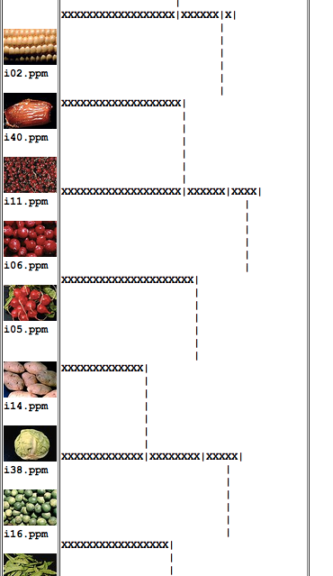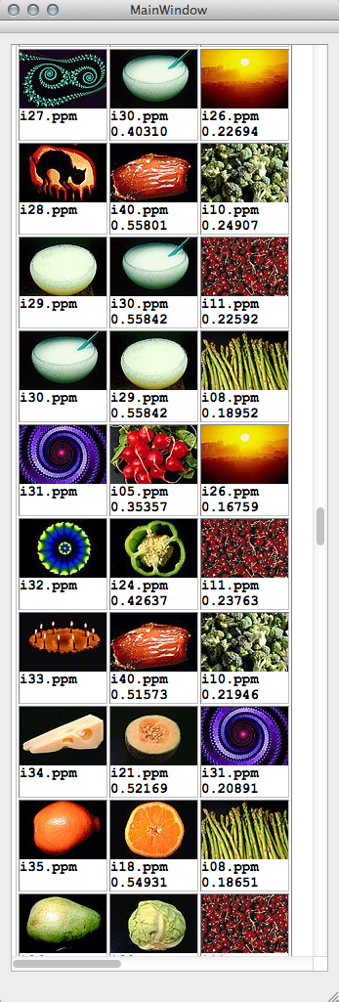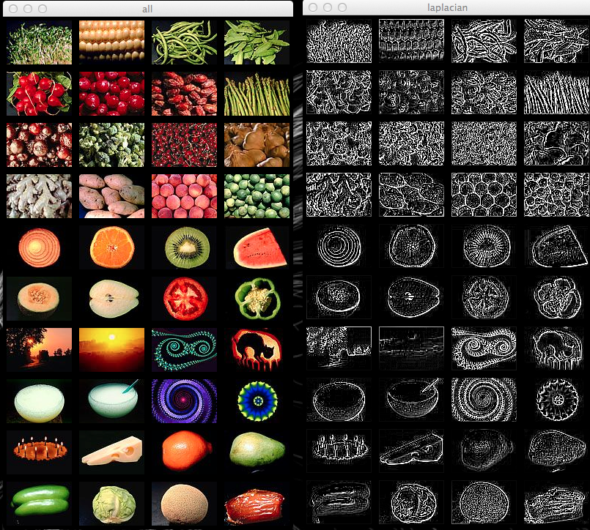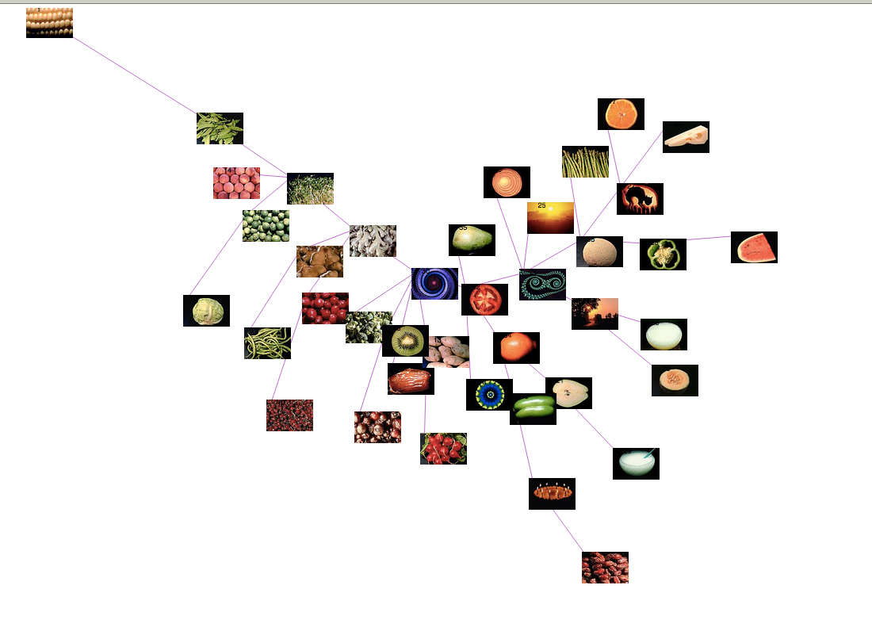 **The project is coded in C++, relying on OpenCV 2.4.3 for computer vision algorithms, and QT 4.8 (and QT Creator) for the design of the GUI forms. Some code and inspiration was found in the OpenCV2 recipes, but the majority of the algorithms are my own implementations, and therefore may not be the best performance wise. For the creativity step I used the D3 JavaScript library and examples to plot the images in real time interactively. For my own reference, I created a GUI with a text pane for outputting the images and dendrograms in HTML, as well as two OpenCV windows, one with a combined view of all the original images, and one of the combined laplacians.**

**All of the code below is in a repository at http://github.com/on2valhalla/ImageMatching**

# Assignment Detail

Step One: Gross Color Matching

For step one, we were instructed to compare the 40 images against each other using a normalized L1 comparison of their RGB histograms on a scale of [0,1] (1 meaning total similarity). We were then to display the images in 3 columns showing the original picture, the best match, and the worst match for each image.

The first choice I made was to implement my own algorithm for creating histograms for the images, after I had library issues with the OpenCV includes early in my work. I finally settled on a bucket size of 10 after comparing the results after implementation with a range of bucket sizes. With such a small database of pictures, a bucket size larger than 16 drives any similarity among colors below .4 in my data. I chose to threshold not only the black pixels, but also provided an option to threshold the white values as well, for future use in the case there is white in the background. Here leaving the background out of consideration helped with the appearance of matching, when pixels with a total R + G + B value of under 75 were encountered, they were simply not totaled in the histogram. I also implemented my own L1 normalization function so that I would have better control over the minimum and maximum values for display purposes.

After collecting the L1 data The matching is obviously not perfect, while there are two more steps, but I am actually impressed with the results that I received. There were still quite a few pairs that had almost no histogram overlap, even with only 10 buckets, which shows that it is not a perfect metric, but the best matches align well with my first impressions of matching in the images. The spinning wheels were notoriously bad matches with other pictures, but that is probably why they are here.

See Addendum on Page <8> for Images and Data

Step Two: Gross Texture Matching

For part two we were to perform the same comparisons on the 40 images but with the histograms of the laplacians of the images. We were to first create a grey-scale image from the RGB (or BGR in OpenCV), and then measure the texture of the images by applying a kernel. **I converted the images to grey-scale with my own algorithm, simply dividing the total R + G + B values by 3 and storing the value.** For this part I attempted to use OpenCV’s linearFilter2D function, but found the results were sub-par. However, their Laplacian function performed better than my own, but it uses a matrix that leaves out the corner values of the 3x3 matrix, which i did not think would be allowed. This allowed me to implement my own kernel after the one described in class. The kernel I used is as below:

$$\left[\begin{matrix}1 & 1 & 1 \\ 1 & -8 & 1 \\ 1 & 1 & 1\end{matrix}\right]$$

**When implementing the Laplacian Histogram function I allowed for a threshold to be set to allow for some kind of “background” filter, but found that a threshold of any value made the matching considerably worse for my algorithm, so I decided to not threshold the laplacians. When you are measuring edginess, it makes sense to leave everything in so you get a better proportion of the whole frame of the image, unlike a flat color like black that is fairly uniform. For these histograms I chose a much larger bucket size, while the range of values was much larger and allowed for more refined comparison. I finally decided on a bucket size of 4000, while with the small amount of pictures we have here, I could afford to sacrifice a little performance for accuracy (anything under 3600 for my algorithm drastically reduced matching while my range of values was -1800 to 1800 from the laplacian).**

**I was also impressed with the texture matches (once you can trick your mind to not pay attention to the color). Again the spinning wheels of color cause issues here because of their strange patterns, but the majority mesh nicely.**

See Addendum on Page <13> for Images and Data

Step Three: Combine Similarities and Cluster

**For part three, we were to take the measurements we had already collected from the L1 normalizations of the color and texture steps and find a ratio to plug into the linear sum comparing them. This is a problem that could be well suited to machine learning, but I did not have access to a larger database of already “verified” images to test against. Instead I did it the old fashioned way, and asked my girlfriend to help me tally up the ratio choices that had different best matches, giving a point to the ratio that had the best match. On ~90% of the images there was no difference between these ratios, but the fine tuning of the algorithm can drop the outliers out of the equation. I finally decided on a .5/.5 ratio for the color and texture, while the .25 case had a few outliers that I did not like. Hence these measurements from such a small dataset are highly subjective. Here are the results I found:**

|  |  |  |  |  |
| --- | --- | --- | --- | --- |
| **Ratio (r * Color) ((1-r) * Texture):** | 0.25 | 0.5 | 0.75 | 1 |
| **Total Differing Better Matches:** | **11** | **10** | **7** | **6** |

**For the clustering step, I again implemented my own algorithm allowing for one function to cluster on either complete or single link algorithms (while there is only a comparison step change between them). The dendrogram was probably my least favorite part of this assignment, and I made a poor choice to try and represent it in ASCII like on the assignment sheet. With A LOT of tweaking I finally got something acceptable to output, but the conversion from the QTextEdit pane to HTML again messes all alignment up, so after a few hours I stopped messing with it. I realize now I could have used a drawing package and drawn the lines, but I have already put too much work into this step.**

**I can however still notice that the single link algorithm is a much worse clustering, especially in the creativity step below. It seems that with single link simply adds the next nearest, and so therefore not really clustering, but as mentioned in the notes, is more like a minimum spanning tree.**

See Addendum on Page <18> for Images and Data

Part 4: Creativity with D3 mapping

**For the creativity step of this assignment, I decided to use the D3 JavaScript library, that provides interactive force directed graphs straight from your web browser. I created a tree structure, and a output function that will successfully fill in a JSON file to match the requirements of a standard D3 force directed graph script. This allows for variable adjustment and tweaking. I have found that the most interesting comparisons this creates is between the two clustering methods above, where the complete link method is represented by a fairly diverse graph, with branches to the edge of the frame, while the single link method is the least similar photo in the middle surrounded by the majority at a closed length circle with a few on the periphery.**

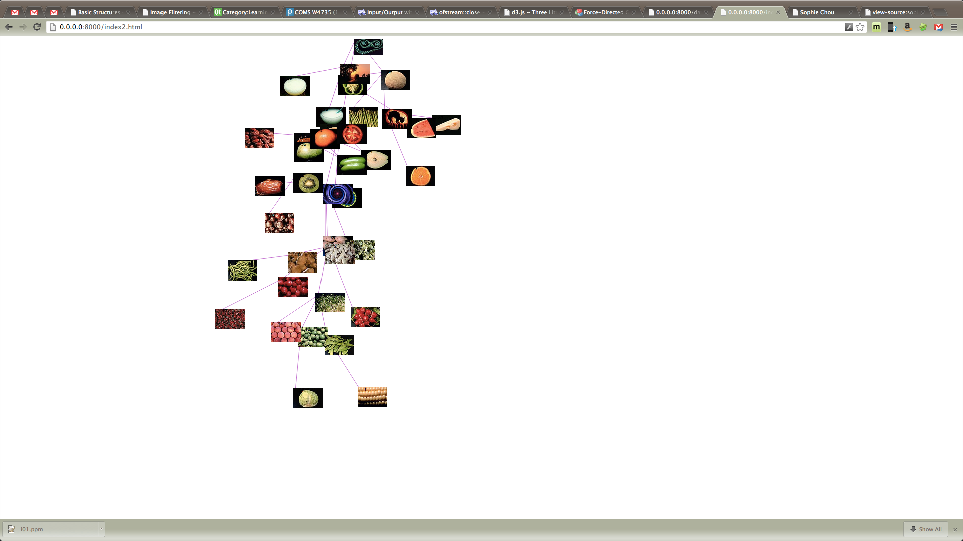 **This method of graphing the photos is not only interesting because of its versatility (easily shifting a constant up or down creates different interactions) but it is also interactive, such that you can click on any of the photos, and drag them around to show the ties that photo has to others. Also I have graphed all the links from the data gained by the color, texture and the combination functions, but the grouping is more of an average, while each node is pulled by every other node. The dendrograms are on page 22 and 28 respectively.**

**Single Link Clustering: Mapping all links from Combo Data:**

# Output



# Code

ImageMatching.pro

#-------------------------------------------------

#

# Project created by QtCreator 2013-03-08T22:21:41

#

#-------------------------------------------------

QT += core gui

QMAKE_CXXFLAGS += -fpermissive

greaterThan(QT_MAJOR_VERSION, 4): QT += widgets

TARGET = ImageMatching

TEMPLATE = app

SOURCES += main.cpp\

mainwindow.cpp \

dendnode.cpp

HEADERS += mainwindow.h\

utils.h \

dendnode.h

FORMS += mainwindow.ui

INCLUDEPATH += /opt/local/include/

LIBS += -L/opt/local/lib/ \

-lopencv_core \

-lopencv_highgui \

-lopencv_imgproc \

-lopencv_features2d \

-lopencv_objdetect \

-lopencv_calib3d

main.cpp

/*

Created by: Jason Carlisle Mann (on2valhalla | jcm2207@columbia.edu)

Main for the Image Matching program

*/

//QT

#include <QApplication>

#include "mainwindow.h"

using namespace std;

int main(int argc, char *argv[])

{

QApplication a(argc, argv);

MainWindow w;

w.show();

w.run();

return a.exec();

}

mainwindow.h

/*

Created by: Jason Carlisle Mann (on2valhalla | jcm2207@columbia.edu)

MainWindow header for the Image Matching program

*/

#ifndef MAINWINDOW_H

#define MAINWINDOW_H

#include <QMainWindow>

#include <QTextCursor>

#include <QTextDocumentWriter>

//OpenCV

#include <opencv2/core/core.hpp>

#include <opencv2/highgui/highgui.hpp>

//SYS

#include <vector>

#include <string>

#include <iostream>

#include <cmath>

#include "dendnode.h"

namespace Ui {

class MainWindow;

}

using namespace std;

using namespace cv;

class MainWindow : public QMainWindow

{

Q_OBJECT

public:

explicit MainWindow(QWidget *parent = 0);

~MainWindow();

void colorMatch(vector<string> &fileNames, vector<Mat> &images,

Mat &colorVals);

void textureMatch(vector<string> &fileNames, vector<Mat> &images,

Mat &textureVals);

void comboMatch(vector<string> &fileNames,

Mat &colorVals, Mat &textureVals, Mat &comboVals);

DendNode* linkage( Mat & comboVals, int linkageType = 0);

int drawDendrogram(QTextCursor &texCurs, QTextCursor &imgCurs, vector<string> &imgNames,

DendNode *tree, int totWidth = 40, int startWidth =100);

void run();

static const bool DISPLAY = false;

private:

Ui::MainWindow *ui;

};

#endif // MAINWINDOW_H

mainwindow.cpp

/*

Created by: Jason Carlisle Mann (on2valhalla | jcm2207@columbia.edu)

Main Window for the Image Matching program

*/

//local

#include "mainwindow.h"

#include "ui_mainwindow.h"

#include "utils.h"

using namespace util;

MainWindow::MainWindow(QWidget *parent) :

QMainWindow(parent),

ui(new Ui::MainWindow)

{

ui->setupUi(this);

}

MainWindow::~MainWindow()

{

delete ui;

}

void MainWindow::run()

{

//Retrieve the images from the filesystem

vector<string> fileNames;

vector<Mat> images;

getImages(images, fileNames, IMG_DIR, NUM_IMAGES);

// -1 for y val because you dont want to include self match

// it messes with the minmax function (see inside for workaround)

Mat colorVals(NUM_IMAGES, NUM_IMAGES -1, CV_32F);

Mat textureVals(NUM_IMAGES, NUM_IMAGES -1, CV_32F);

Mat comboVals(NUM_IMAGES, NUM_IMAGES -1, CV_32F);

QTextCursor curs = this->ui->textEdit->textCursor();

curs.insertText("COLOR\n---------\n");

colorMatch(fileNames, images, colorVals);

textureMatch(fileNames, images, textureVals);

comboMatch(fileNames, colorVals, textureVals, comboVals);

// convert the combination values to distances

// and disregard matches to same element

// (2 is out of range for min)

comboVals = 1 - comboVals;

for (int i = 0; i < comboVals.rows; i++)

comboVals.at<float>(i,i) = 2;

DendNode *completeTree = linkage(comboVals, 0);

DendNode *singleTree = linkage(comboVals, 1);

completeTree->toJson("/Users/on2valhalla/Documents/school/Visual Interfaces/QTest/ImageMatching/completeLink.json");

singleTree->toJson("/Users/on2valhalla/Documents/school/Visual Interfaces/QTest/ImageMatching/singleLink.json");

comboVals = 1 - comboVals;

matToJson(comboVals, "/Users/on2valhalla/Documents/school/Visual Interfaces/QTest/ImageMatching/allLinks.json");

if(DISPLAY)

{

QTextCursor curs = this->ui->textEdit->textCursor();

curs.insertText("\n\n\n\nDendrogram For Complete Link");

curs.insertTable(1,2);

QTextCursor imgCurs(curs);

curs.movePosition(QTextCursor::NextCell);

curs.insertText("\n\n");

drawDendrogram(curs, imgCurs, fileNames, completeTree, 40, 0);

curs.movePosition(QTextCursor::End);

curs.insertText("\n\n\n\nDendrogram For Single Link");

curs.insertTable(1,2);

imgCurs = curs;

curs.movePosition(QTextCursor::NextCell);

curs.insertText("\n\n");

drawDendrogram(curs, imgCurs, fileNames, singleTree, 100, 0);

}

// To write the contents of the textEdit to an html file

// QTextDocument* document = this->ui->textEdit->document();

// QTextDocumentWriter writer("/Users/on2valhalla/Documents/school/Visual Interfaces/someFile.html", "HTML");

// if (!writer.write(document))

// {

// cout << "error";

// }

}

void MainWindow::colorMatch(vector<string> &fileNames, vector<Mat> &images,

Mat &colorVals)

{

const int BUCKETS = 10, B_THRESH = 30, W_THRESH = 0;

//get their respective histograms

vector<Mat> histograms;

getHistograms(images, histograms, BUCKETS, B_THRESH, W_THRESH);

//will hold the normalized L1 comparison data

double locals[NUM_IMAGES][2][2];

double globals[2][3];

calcL1Norm(histograms, locals, globals, colorVals);

if(DISPLAY)

{

QTextCursor curs = this->ui->textEdit->textCursor();

curs.insertText("COLOR\n---------\n");

displayResults(curs, fileNames, colorVals);

Mat bigImage = manyToOne(images, 10, 4);

namedWindow("all");

imshow("all", bigImage);

}

}

void MainWindow::textureMatch(vector<string> &fileNames, vector<Mat> &images,

Mat &textureVals)

{

int NUM_IMAGES = images.size();

//will hold processed histograms

vector<Mat> histograms(NUM_IMAGES);

vector<Mat> laplacians(NUM_IMAGES);

// for testing the min and max ranges of the laplacians

// Mat minMax(NUM_IMAGES, 2, CV_32F);

for (int i = 0; i < NUM_IMAGES; i++)

{

// convert image to greyscale

Mat grey;

bgrToGrey(images[i], grey);

// apply the laplacian kernel

Mat laplacian;

applyLaplacian(grey, laplacian);

// // FOR TESTING

// // find local and global max

// double min =0, max =0;

// minMaxIdx(laplacian, &min, &max);

// minMax.at<float>(i,0) = min;

// minMax.at<float>(i,1) = max;

// Scalar avg = mean(laplacian);

// this->ui->textEdit->append(QString("i: %3\tmin: %1\tavg: %4\tmax: %2")

// .arg(min,5,'f').arg(max).arg(i).arg(avg[0]*100,5,'f'));

// HISTOGRAM the laplacian

Mat histogram;

getLaplaceHistogram(laplacian, histogram);

// add the histogram to the vector

histograms[i] = histogram;

// keep the laplacian for display

laplacian *= 1./200;

laplacians[i] = laplacian;

}

// // FOR TESTING

// // for testing global maxs for laplacian

// double min =0, max =0;

// minMaxIdx(minMax, &min, &max);

// this->ui->textEdit->append(QString("global min: %1\tglobal max: %2")

// .arg(min).arg(max));

// calculate the normalized L1 comparison of the histograms

double locals[NUM_IMAGES][2][2], globals[2][3];

calcL1Norm(histograms, locals, globals, textureVals);

if(DISPLAY)

{

// display the results

QTextCursor curs = this->ui->textEdit->textCursor();

curs.insertText("\n\n\nTEXTURE\n---------\n");

displayResults(curs, fileNames, textureVals);

// display the laplacian images

Mat bigImage = manyToOne(laplacians, 10, 4);

namedWindow("laplacian");

imshow("laplacian", bigImage);

}

}

void MainWindow::comboMatch(vector<string> &fileNames,

Mat &colorVals, Mat &textureVals, Mat &comboVals)

{

float r = .5, s = 1.0;

QTextCursor curs = this->ui->textEdit->textCursor();

for (int i = 0; i < NUM_IMAGES; i ++)

for (int j = 0; j < NUM_IMAGES; j ++)

{

// keep track of all the values

if(j < i)

{

float colorVal = colorVals.at<float>(i,j);

float textureVal = textureVals.at<float>(i,j);

float comboVal = (r * colorVal) + ((s - r) * textureVal);

comboVals.at<float>(i, j) = comboVal;

}

else if(j > i)

{

float colorVal = colorVals.at<float>(i,j-1);

float textureVal = textureVals.at<float>(i,j-1);

float comboVal = (r * colorVal) + ((s - r) * textureVal);

comboVals.at<float>(i, j-1) = comboVal;

}

}

if(DISPLAY)

{

curs.insertText("\n\n\nCOMBO\n---------\n");

displayResults(curs, fileNames, comboVals);

}

}

// Clustering images together based on their similarity data

// linkage type = 0 for complete link

// linkage type = 1 for single link

DendNode* MainWindow::linkage(Mat &comboVals, int linkageType)

{

// initialize a node on the list for every image

list<DendNode*> nodes;

for (int i = 0; i < NUM_IMAGES; i++)

{

DendNode *node = new DendNode(i);

nodes.push_back(node);

}

// loop until only one element remains

while (nodes.size() > 1)

{

/*

for every node in the list, check the rest of the list

for the minimum match... remember to check all the children

of every node (all indicies are contained in a childIndicies

list)

*/

float min = 2;

list<DendNode*>::iterator it, jt, mini, minj;

for (it = nodes.begin(); it != nodes.end(); it++)

for (jt = nodes.begin(); jt != nodes.end(); jt++)

{

if(it == jt)

continue;

float match;

if(linkageType == 0)

match = (*it)->maxMatch( *jt, comboVals );

else

match = (*it)->minMatch( *jt, comboVals );

if( match < min)

{

min = match;

mini = it;

minj = jt;

}

}

// Once the min value and indicies are found, create a new node

// with the two indicies as children

DendNode *match = new DendNode(*mini, *minj, min);

nodes.erase(mini);

nodes.erase(minj);

nodes.push_back(match);

}

// pop the final node

DendNode* root = *nodes.begin();

return root;

}

// Draw the created dendrogram from the root node (recursive)

// Note: Very finicky.... dont mess with the spacing

int MainWindow::drawDendrogram(QTextCursor &texCurs,QTextCursor &imgCurs, vector<string> &imgNames,

DendNode *tree, int width, int startWidth)

{

if (tree->distance == -1)

{

int i = tree->getIdx();

QImage image(imgNames[i].c_str());

imgCurs.insertImage(image);

if (i % 4 == 0)

imgCurs.insertText(QString("\n%1\n\n\n").arg(imgNames[i].c_str()));

else

imgCurs.insertText(QString("\n%1\n\n").arg(imgNames[i].c_str()));

return 0;

}

int baseD = (int)(tree->distance * width);

// in order recursive traversal

int leftD = drawDendrogram(texCurs, imgCurs, imgNames, tree->left, width, startWidth);

//draw linkage

int length = baseD - leftD;

for (int i = 0; i < length; ++i)

texCurs.insertText("X");

texCurs.insertText("▼\n");

for(int j = 0; j < 6; j++)

{

for (int i = 0; i < baseD+2; i++)

texCurs.insertText(" ");

texCurs.insertText("|\n");

}

// fill in the right node

int rightD = drawDendrogram(texCurs, imgCurs, imgNames, tree->right, width, startWidth);

if(rightD != leftD)

length = baseD - rightD;

for (int i = 0; i < length; i++)

texCurs.insertText("X");

texCurs.insertText("▲");

return baseD;

}

mainwindow.ui

<?xml version="1.0" encoding="UTF-8"?>

<ui version="4.0">

<class>MainWindow</class>

<widget class="QMainWindow" name="MainWindow">

<property name="geometry">

<rect>

<x>0</x>

<y>0</y>

<width>722</width>

<height>632</height>

</rect>

</property>

<property name="windowTitle">

<string>MainWindow</string>

</property>

<widget class="QWidget" name="centralWidget">

<property name="sizePolicy">

<sizepolicy hsizetype="Expanding" vsizetype="Expanding">

<horstretch>100</horstretch>

<verstretch>100</verstretch>

</sizepolicy>

</property>

<layout class="QVBoxLayout" name="verticalLayout">

<item>

<widget class="QTextEdit" name="textEdit">

<property name="sizePolicy">

<sizepolicy hsizetype="Expanding" vsizetype="Expanding">

<horstretch>100</horstretch>

<verstretch>100</verstretch>

</sizepolicy>

</property>

<property name="font">

<font>

<family>Courier New</family>

<pointsize>14</pointsize>

<weight>75</weight>

<bold>true</bold>

</font>

</property>

<property name="lineWrapMode">

<enum>QTextEdit::NoWrap</enum>

</property>

</widget>

</item>

</layout>

</widget>

<widget class="QMenuBar" name="menuBar">

<property name="geometry">

<rect>

<x>0</x>

<y>0</y>

<width>722</width>

<height>22</height>

</rect>

</property>

</widget>

<widget class="QToolBar" name="mainToolBar">

<attribute name="toolBarArea">

<enum>TopToolBarArea</enum>

</attribute>

<attribute name="toolBarBreak">

<bool>false</bool>

</attribute>

</widget>

<widget class="QStatusBar" name="statusBar"/>

</widget>

<layoutdefault spacing="6" margin="11"/>

<resources/>

<connections/>

</ui>

utils.h

/*

Created by: Jason Carlisle Mann (on2valhalla | jcm2207@columbia.edu)

A utility class containing useful tools for interacting with images in

QT and OpenCV, as well as providing other functions for Image Matching

*/

#ifndef UTILS_H

#define UTILS_H

//QT

#include <QTextCursor>

//OpenCV

#include <opencv2/core/core.hpp>

#include <opencv2/highgui/highgui.hpp>

//SYS

#include <vector>

#include <string>

#include <iostream>

namespace util

{

using namespace std;

using namespace cv;

static const string IMG_DIR = "../../../../ImageMatching/img/";

static const int NUM_IMAGES = 40;

//copies many images to one image

//all images must be the same size as the first

Mat manyToOne(vector<Mat> &images, int numRows, int numCols)

{

Mat sampleImage = images[0];

int imageWidth = sampleImage.cols;

int imageHeight = sampleImage.rows;

int buffer = 5;

int bigWidth = numRows * (imageHeight + 2*buffer);

int bigHeight = numCols * (imageWidth + 2*buffer);

Mat bigImage ( bigWidth, bigHeight, sampleImage.type());

for (unsigned int i = 0; i < images.size(); i++)

{

int row = i / numCols;

int col = i % numCols;

int x = col * imageWidth + 2*col*buffer + buffer;

int y = row * imageHeight + 2*row*buffer + buffer;

Mat roi(bigImage, Rect(x, y, imageWidth, imageHeight));

images[i].copyTo(roi);

}

return bigImage;

}

//Gets number of images from a specified directory

void getImages(vector<Mat> &images, vector<string> &fileNames, string dir, int count)

{

for (int i = 1; i <= count; i++)

{

stringstream sstm;

if( i >= 10)

sstm << dir << "i" << i << ".ppm";

else

sstm << dir << "i0" << i << ".ppm";

string fileName = sstm.str();

fileNames.push_back(fileName);

Mat image = imread(fileName, 1);

images.push_back(image);

}

}

// take a list of images and give back histograms

//

void getHistograms(const vector<Mat> &images, vector<Mat> &histograms, int buckets = 10, int blackThresh = 25, int whiteThresh = 25)

{

const int histSize[] = {buckets, buckets, buckets};

for (unsigned int i = 0; i < images.size(); i++)

{

Mat image = images[i];

Mat histogram(3, histSize, CV_32F, Scalar(0));

CV_Assert(image.type() == CV_8UC3);

int numPixels = 0;

for (int j = 0; j < image.rows; j++)

for (int k = 0; k < image.cols; k++)

{

const Vec3b& pix = image.at<Vec3b>(j,k);

//threshold black values by skipping them

if(pix[0] + pix[1] + pix[2] < blackThresh*3)

continue;

//threshold white values by skipping them

if(pix[0] + pix[1] + pix[2] > (255 - whiteThresh)*3 )

continue;

histogram.at<float>(pix[0]*buckets/256, pix[1]*buckets/256, pix[2]*buckets/256) += 1.0;

numPixels +=1;

}

//Get a 3d iterator that returns a Mat that is

//a slice (plane) of the original nary matrix

cv::Mat plane;

const cv::Mat* hists[] = { &histogram, 0 };

cv::NAryMatIterator itN(hists, &plane, 1);

//Normalize the histogram

double normRatio = 1./numPixels;

for(unsigned int p = 0; p < itN.nplanes; p++, ++itN)

itN.planes[0] *= normRatio;

histograms.push_back(histogram);

}

}

// calculate the L1 norm of all the histograms

void calcL1Norm(vector<Mat> &histograms, double locals[NUM_IMAGES][2][2],

double globals[2][3], Mat &allVals)

{

globals[0][0] = 10000; //global min val

globals[1][0] = 0; // global max val

for (int i = 0; i < NUM_IMAGES; i++)

{

locals[i][0][0] = 10000; //local min val

locals[i][1][0] = 0; //local max val

for (int j = 0; j < NUM_IMAGES; j++)

{

// get the l1 norm of the two histograms

double normVal = norm(histograms[i],histograms[j], NORM_L1);

// map the value to [0,1] (1 is the same image)

normVal = 1 - (normVal/2.);

if(normVal < 0)

normVal *= -1;

// keep track of all the values

if(j < i)

allVals.at<float>(i, j) = (float) normVal;

else if(j > i)

allVals.at<float>(i, j-1) = (float) normVal;

// cout << allVals.at<float>(i,j) <<endl;

//hack to make min max work

if( i == j)

continue;

if (normVal < locals[i][0][0])

{

locals[i][0][0] = normVal;

locals[i][0][1] = j;

}

if (normVal > locals[i][1][0])

{

locals[i][1][0] = normVal;

locals[i][1][1] = j;

}

if (normVal < globals[0][0])

{

globals[0][0] = normVal;

globals[0][1] = i;

globals[0][2] = j;

}

if (normVal > globals[1][0])

{

globals[1][0] = normVal;

globals[1][1] = i;

globals[1][2] = j;

}

}

}

}

// converts image to grey

void bgrToGrey(const Mat &image, Mat &grey)

{

// recreate if necessary

grey.create(image.size(), CV_32F);

for( int j = 0; j < image.rows; j++)

for( int k = 0; k < image.cols; k++)

{

const Vec3b& pix = image.at<Vec3b>(j,k);

grey.at<float>(j,k) = (pix[0] + pix[1] + pix[2])/3;

}

}

// input an image in greyscale

void applyLaplacian(const Mat &grey, Mat &laplacian)

{

//make kernel for laplacian

float kernel[3][3] = {{1., 1., 1.},

{1., -8., 1.},

{1., 1., 1.}};

//create the Mat if necessary

laplacian.create(grey.size(), CV_32F);

for( int j = 0; j < grey.rows; j++)

for( int k = 0; k < grey.cols; k++)

{

laplacian.at<float>(j,k) = grey.at<float>(j,k);

//skip the edge elements

if(j == 0 || k == 0 ||

j == grey.rows -1 || k == grey.cols -1)

continue;

//apply kernel

laplacian.at<float>(j,k) *= kernel[1][1];

laplacian.at<float>(j,k) += grey.at<float>(j-1,k-1) * kernel[0][0];

laplacian.at<float>(j,k) += grey.at<float>(j-1,k) * kernel[0][1];

laplacian.at<float>(j,k) += grey.at<float>(j-1,k+1) * kernel[0][2];

laplacian.at<float>(j,k) += grey.at<float>(j,k-1) * kernel[1][0];

laplacian.at<float>(j,k) += grey.at<float>(j,k+1) * kernel[1][2];

laplacian.at<float>(j,k) += grey.at<float>(j-1,k-1) * kernel[2][0];

laplacian.at<float>(j,k) += grey.at<float>(j,k-1) * kernel[2][1];

laplacian.at<float>(j,k) += grey.at<float>(j+1,k-1) * kernel[2][2];

// // testing functionality to find the range

// // for background exclusion

// if(fabs(laplacian.at<float>(j,k)) < 10)

// laplacian.at<float>(j,k) = 1;

// else

// laplacian.at<float>(j,k) = 0;

}

}

void getLaplaceHistogram(const Mat &laplacian, Mat &histogram,

float buckets = 4000, float lapAbsMax = 1800, float laplaceThresh = 12)

{

// init the histogram and clear it out

histogram = Mat(1, buckets, CV_32F, Scalar(0));

int totalPix = 0;

for (int j=0; j <laplacian.rows; j++)

for (int k=0; k <laplacian.rows; k++)

{

//count the pixels for each bucket

float pixel = laplacian.at<float>(j,k);

// //threshold here if you will, but i do not

// if(fabs(pixel) < laplaceThresh)

// continue;

// have to take the negative values into account

int idx = (int) pixel * buckets/(2*lapAbsMax) + buckets/2;

histogram.at<float>(0,idx) += 1.0;

totalPix +=1;

}

// NORMALIZE the histogram

float normRatio = 1./totalPix;

histogram *= normRatio;

}

void displayResults(QTextCursor &curs, vector<string> &fileNames,

Mat &values)

{

//get display images

vector<QImage> qImages(NUM_IMAGES);

for (int i = 0; i< NUM_IMAGES; i++)

qImages[i] = QImage(fileNames[i].c_str());

curs.insertText("Local Matches (Max/Min)");

curs.insertTable(40,3);

for (int i = 0; i< NUM_IMAGES; i++)

{

curs.insertImage(qImages[i]);

curs.insertText("\n" + QString(fileNames[i].c_str()).section("/",-1));

curs.movePosition(QTextCursor::NextCell);

//find min/max

double min, max;

int minIdx[2], maxIdx[2];

minMaxIdx(values.row(i), &min, &max, minIdx, maxIdx);

if( minIdx[1] >= i)

minIdx[1]++;

if( maxIdx[1] >= i)

maxIdx[1]++;

curs.insertImage(qImages[maxIdx[1]]);

curs.insertText("\n" + QString(fileNames[maxIdx[1]].c_str()).section("/",-1)

+ QString("\n%1").arg(max,4,'f',5));

curs.movePosition(QTextCursor::NextCell);

curs.insertImage(qImages[minIdx[1]]);

curs.insertText("\n" + QString(fileNames[minIdx[1]].c_str()).section("/",-1)

+ QString("\n%1").arg(min,4,'f',5));

curs.movePosition(QTextCursor::NextCell);

}

curs.movePosition(QTextCursor::End);

curs.insertText("\n\nGlobal Matches (Max/Min)");

curs.insertTable(2,2);

//find min/max

double min, max;

int minIdx[2], maxIdx[2];

minMaxIdx(values, &min, &max, minIdx, maxIdx);

if(minIdx[1] >= minIdx[0])

minIdx[1]++;

if(maxIdx[1] >= maxIdx[0])

maxIdx[1]++;

curs.insertImage(qImages[maxIdx[0]]);

curs.insertText("\n" + QString(fileNames[maxIdx[0]].c_str()).section("/",-1)

+ QString("\n%1").arg(max));

curs.movePosition(QTextCursor::NextCell);

curs.insertImage(qImages[maxIdx[1]]);

curs.insertText("\n" + QString(fileNames[maxIdx[1]].c_str()).section("/",-1)

+ QString("\n%1").arg(max));

curs.movePosition(QTextCursor::NextCell);

curs.insertImage(qImages[minIdx[0]]);

curs.insertText("\n" + QString(fileNames[minIdx[0]].c_str()).section("/",-1)

+ QString("\n%1").arg(min));

curs.movePosition(QTextCursor::NextCell);

curs.insertImage(qImages[minIdx[1]]);

curs.insertText("\n" + QString(fileNames[minIdx[1]].c_str()).section("/",-1)

+ QString("\n%1").arg(min));

curs.movePosition(QTextCursor::NextCell);

}

// The parameter data should be representative of distance and normalized

static const float VALUE = 10.;

void matToJson(cv::Mat &data, std::string fileName)

{

std::ofstream outputFile;

std::cout << "Writing JSON to: " << fileName <<std::endl;

outputFile.open(fileName.c_str(), std::ofstream::trunc | std::ofstream::out);

outputFile << "{\"nodes\":[\n";

for (int i = 1; i <= data.rows; i++)

{

outputFile << "\t{\"name\":" << "\"" << i << "\", \"group\":" << i / 10 ;

if(i < 10)

outputFile << ", \"img\":\"http://0.0.0.0:8000/img/i0" << i << ".jpg\"}, \n";

else

outputFile <<", \"img\":\"http://0.0.0.0:8000/img/i" << i << ".jpg\"}, \n";

}

// remove the comma

long pos = outputFile.tellp();

outputFile.seekp(pos-3);

outputFile << "\n],\n" << "\"links\":[\n";

for (int i = 0; i < data.rows; i++)

for (int j = 0; j < data.rows; j++)

{

if (i == j)

continue;

outputFile << "\t{\"source\":" << i << ", \"target\":" << j

<< ", \"value\":" << data.at<float>(i,j) * VALUE << "}, \n";

}

// remove the comma

pos = outputFile.tellp();

outputFile.seekp(pos-3);

outputFile << "\n]}";

outputFile.close();

}}

#endif // UTILS_H

dendnode.h

/*

Created by: Jason Carlisle Mann (on2valhalla | jcm2207@columbia.edu)

A Node class for making dendrograms, as well as displaying with D3

*/

#ifndef DENDNODE_H

#define DENDNODE_H

#include <string>

#include <vector>

#include <stack>

#include <iostream>

#include <fstream>

#include <cmath>

#include <opencv2/core/core.hpp>

class DendNode

{

public:

static const float VALUE = 1.0;

double distance;

DendNode *left;

DendNode *right;

std::vector<int> idxs;

DendNode()

{

distance = -1;

left = NULL;

right = NULL;

}

DendNode(int idx)

{

distance = -1;

idxs.push_back(idx);

left = NULL;

right = NULL;

}

DendNode(DendNode *l, DendNode *r, double matchD)

{

distance = matchD;

left = l;

right = r;

idxs.insert(idxs.begin(),

l->idxs.begin(), l->idxs.end());

idxs.insert(idxs.begin(),

r->idxs.begin(), r->idxs.end());

}

DendNode(const DendNode &node)

{

distance = node.distance;

left = node.left;

right = node.right;

idxs = node.idxs;

}

~DendNode()

{

if( left != NULL)

delete left;

if( right != NULL)

delete right;

}

friend std::ostream& operator<< (std::ostream &o, const DendNode &n);

// finds the maximum match between two nodes (possibly trees)

// by checking the lookup Mat provided

float maxMatch(const DendNode* node, const cv::Mat &lookup)

{

float max = 0;

std::vector<int>::iterator it = idxs.begin();

std::vector<int>::const_iterator jt;

for (; it != idxs.end(); it++)

for (jt = node->idxs.begin(); jt != node->idxs.end(); jt++)

if (lookup.at<float>(*it, *jt) > max)

max = lookup.at<float>(*it, *jt);

return max;

}

// finds the minimum match between two nodes (possibly trees)

// by checking the lookup Mat provided

float minMatch(const DendNode* node, const cv::Mat &lookup)

{

float min = 2;

std::vector<int>::iterator it = idxs.begin();

std::vector<int>::const_iterator jt;

for (; it != idxs.end(); it++)

for (jt = node->idxs.begin(); jt != node->idxs.end(); jt++)

if (lookup.at<float>(*it, *jt) < min)

min = lookup.at<float>(*it, *jt);

return min;

}

int getIdx()

{

if(idxs.size() > 1)

return -1;

return idxs[0];

}

void toJson(std::string fileName);

int recursiveWriter(DendNode *node, std::ofstream &file,

std::stringstream &links, int *group, float *distTrack);

};

#endif // DENDNODE_H

dendnode.cpp

/*

Created by: Jason Carlisle Mann (on2valhalla | jcm2207@columbia.edu)

Dendnode source

*/

#include "dendnode.h"

std::ostream& operator<< (std::ostream &o, const DendNode &n)

{

o << "{ ";

for (std::vector<int>::const_iterator it = n.idxs.begin(); it != n.idxs.end(); it++)

o << *it << ", ";

o << "} d:" << n.distance;

return o;

}

//creates a JSON file representing this tree for D3 mapping

void DendNode::toJson(std::string fileName)

{

std::ofstream outputFile;

std::stringstream links;

std::cout << "Writing JSON to: " << fileName << std::endl;

outputFile.open(fileName.c_str(), std::ofstream::trunc | std::ofstream::out);

outputFile << "{\"nodes\":[\n";

links << "\"links\":[\n";

int group = 0;

float distTrack = 0;

recursiveWriter(this, outputFile, links, &group, &distTrack);

//join the nodes and the links

//get rid of final commas

long pos = outputFile.tellp();

outputFile.seekp(pos-3);

pos = links.tellp();

links.seekp(pos-3);

links << "\n";

std::string linkStr = links.str();

outputFile << "\n],\n" << linkStr << "]}";

outputFile.close();

}

int DendNode::recursiveWriter(DendNode *node, std::ofstream &file, std::stringstream &links, int *group, float *distTrack)

{

// leaf node terminating condition

if (node->distance == -1)

{

int idx = node->idxs[0] +1;

std::string addr;

if(idx< 10)

addr = ", \"img\":\"http://0.0.0.0:8000/img/i0";

else

addr = ", \"img\":\"http://0.0.0.0:8000/img/i";

file << "\t{\"name\":" << "\"" << idx << "\", \"group\":" << *group

<< addr << idx << ".jpg\"}, \n";

return idx -1;

}

if (fabs(*distTrack - node->distance) > .05)

{

*distTrack = node->distance;

(*group)++;

}

int left = recursiveWriter(node->left, file, links, group, distTrack);

int right = recursiveWriter(node->right, file, links, group, distTrack);

links << "\t{\"source\":" << left << ", \"target\":" << right

<< ", \"value\":" << (1-node->distance) * VALUE << "}, \n";

return (left > right) ? left : right;

}

completeLink.html

<!-- /*

Modified by: Jason Carlisle Mann (on2valhalla | jcm2207@columbia.edu)

Based off of the D3 API Example for a Force Directed Graph

*/ -->

<!DOCTYPE html>

<meta charset="utf-8">

<script src="http://d3js.org/d3.v2.min.js?2.9.3"></script>

<style>

.link {

stroke: #BBB;

}

.node text {

pointer-events: none;

font: 10px sans-serif;

}

</style>

<body>

<script>

var width = 1900,

height = 1200

var svg = d3.select("body").append("svg")

.attr("width", width)

.attr("height", height);

var force = d3.layout.force()

.gravity(.01)

.distance(function(d) { return d.value * 150; })

.charge(0)

.size([width, height]);

d3.json("allLinks.json", function(json) {

force

.nodes(json.nodes)

.links(json.links)

.start();

var link = svg.selectAll(".link")

.data(json.links)

.enter().append("line")

.attr("class", "link");

var node = svg.selectAll(".node")

.data(json.nodes)

.enter().append("g")

.attr("class", "node")

.call(force.drag);

node.append("image")

.attr("xlink:href", function(d) {return d.img})

.attr("x", -8)

.attr("y", -8)

.attr("width", 89)

.attr("height", 60);

node.append("text")

.attr("dx", 12)

.attr("dy", ".35em")

.text(function(d) { return d.name });

force.on("tick", function() {

link.attr("x1", function(d) { return d.source.x; })

.attr("y1", function(d) { return d.source.y; })

.attr("x2", function(d) { return d.target.x; })

.attr("y2", function(d) { return d.target.y; });

node.attr("transform", function(d) { return "translate(" + d.x + "," + d.y + ")"; });

});

});

</script>

completeLink.json

{"nodes":[

{"name":"2", "group":5, "img":"http://0.0.0.0:8000/img/i02.jpg"},

{"name":"40", "group":5, "img":"http://0.0.0.0:8000/img/i40.jpg"},

{"name":"11", "group":5, "img":"http://0.0.0.0:8000/img/i11.jpg"},

{"name":"6", "group":5, "img":"http://0.0.0.0:8000/img/i06.jpg"},

{"name":"5", "group":5, "img":"http://0.0.0.0:8000/img/i05.jpg"},

{"name":"14", "group":6, "img":"http://0.0.0.0:8000/img/i14.jpg"},

{"name":"38", "group":6, "img":"http://0.0.0.0:8000/img/i38.jpg"},

{"name":"16", "group":8, "img":"http://0.0.0.0:8000/img/i16.jpg"},

{"name":"4", "group":9, "img":"http://0.0.0.0:8000/img/i04.jpg"},

{"name":"3", "group":9, "img":"http://0.0.0.0:8000/img/i03.jpg"},

{"name":"10", "group":10, "img":"http://0.0.0.0:8000/img/i10.jpg"},

{"name":"15", "group":10, "img":"http://0.0.0.0:8000/img/i15.jpg"},

{"name":"1", "group":12, "img":"http://0.0.0.0:8000/img/i01.jpg"},

{"name":"9", "group":12, "img":"http://0.0.0.0:8000/img/i09.jpg"},

{"name":"12", "group":13, "img":"http://0.0.0.0:8000/img/i12.jpg"},

{"name":"13", "group":13, "img":"http://0.0.0.0:8000/img/i13.jpg"},

{"name":"7", "group":14, "img":"http://0.0.0.0:8000/img/i07.jpg"},

{"name":"8", "group":14, "img":"http://0.0.0.0:8000/img/i08.jpg"},

{"name":"30", "group":17, "img":"http://0.0.0.0:8000/img/i30.jpg"},

{"name":"29", "group":17, "img":"http://0.0.0.0:8000/img/i29.jpg"},

{"name":"18", "group":19, "img":"http://0.0.0.0:8000/img/i18.jpg"},

{"name":"34", "group":19, "img":"http://0.0.0.0:8000/img/i34.jpg"},

{"name":"22", "group":20, "img":"http://0.0.0.0:8000/img/i22.jpg"},

{"name":"21", "group":21, "img":"http://0.0.0.0:8000/img/i21.jpg"},

{"name":"33", "group":21, "img":"http://0.0.0.0:8000/img/i33.jpg"},

{"name":"36", "group":23, "img":"http://0.0.0.0:8000/img/i36.jpg"},

{"name":"37", "group":23, "img":"http://0.0.0.0:8000/img/i37.jpg"},

{"name":"32", "group":23, "img":"http://0.0.0.0:8000/img/i32.jpg"},

{"name":"20", "group":24, "img":"http://0.0.0.0:8000/img/i20.jpg"},

{"name":"24", "group":25, "img":"http://0.0.0.0:8000/img/i24.jpg"},

{"name":"35", "group":25, "img":"http://0.0.0.0:8000/img/i35.jpg"},

{"name":"26", "group":26, "img":"http://0.0.0.0:8000/img/i26.jpg"},

{"name":"28", "group":27, "img":"http://0.0.0.0:8000/img/i28.jpg"},

{"name":"39", "group":27, "img":"http://0.0.0.0:8000/img/i39.jpg"},

{"name":"25", "group":30, "img":"http://0.0.0.0:8000/img/i25.jpg"},

{"name":"17", "group":30, "img":"http://0.0.0.0:8000/img/i17.jpg"},

{"name":"27", "group":30, "img":"http://0.0.0.0:8000/img/i27.jpg"},

{"name":"19", "group":32, "img":"http://0.0.0.0:8000/img/i19.jpg"},

{"name":"23", "group":32, "img":"http://0.0.0.0:8000/img/i23.jpg"},

{"name":"31", "group":32, "img":"http://0.0.0.0:8000/img/i31.jpg"}

],

"links":[

{"source":1, "target":39, "value":0.56968},

{"source":39, "target":10, "value":0.468618},

{"source":5, "target":4, "value":0.53894},

{"source":39, "target":5, "value":0.380454},

{"source":13, "target":37, "value":0.507739},

{"source":39, "target":37, "value":0.354717},

{"source":3, "target":2, "value":0.663725},

{"source":15, "target":3, "value":0.465115},

{"source":9, "target":14, "value":0.573798},

{"source":15, "target":14, "value":0.334054},

{"source":0, "target":8, "value":0.626231},

{"source":11, "target":12, "value":0.461055},

{"source":8, "target":12, "value":0.378098},

{"source":6, "target":7, "value":0.630446},

{"source":12, "target":7, "value":0.33368},

{"source":15, "target":12, "value":0.294826},

{"source":39, "target":15, "value":0.258486},

{"source":29, "target":28, "value":0.558418},

{"source":17, "target":33, "value":0.549309},

{"source":20, "target":32, "value":0.521689},

{"source":21, "target":32, "value":0.469705},

{"source":33, "target":32, "value":0.3715},

{"source":29, "target":33, "value":0.353827},

{"source":35, "target":36, "value":0.649518},

{"source":36, "target":31, "value":0.406914},

{"source":33, "target":36, "value":0.327912},

{"source":23, "target":34, "value":0.616876},

{"source":19, "target":34, "value":0.421415},

{"source":36, "target":34, "value":0.305449},

{"source":27, "target":38, "value":0.558013},

{"source":25, "target":38, "value":0.355781},

{"source":36, "target":38, "value":0.239229},

{"source":24, "target":16, "value":0.554659},

{"source":24, "target":26, "value":0.475262},

{"source":18, "target":22, "value":0.576771},

{"source":22, "target":30, "value":0.350698},

{"source":26, "target":30, "value":0.270833},

{"source":38, "target":30, "value":0.20891},

{"source":39, "target":38, "value":0.133646}

]}